**SQL Murder Mystery**

To solve this case, we'll need to query the police department's database to retrieve the crime scene report for the murder that occurred on Jan. 15, 2018 in SQL City. Based on the database schema provided in the image, we should focus on the crime_scene_report table.

Let's write a SQL query to fetch the relevant crime scene report:

**SELECT \***

**FROM crime_scene_report**

**WHERE date = 20180115**

**AND type = 'murder'**

**AND city = 'SQL City';**

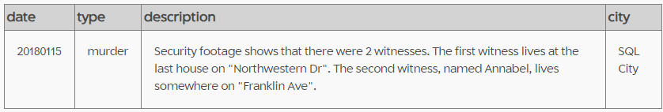

Now that we have this information, we can proceed with our investigation by trying to identify these witnesses.

We'll need to use the person table to find more details about them. Let's start with two separate queries to identify each witness:

For the first witness:

**SELECT \***

**FROM person**

**WHERE address_street_name = 'Northwestern Dr'**

**ORDER BY address_number DESC**

**LIMIT 1;**

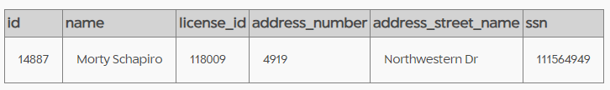

For the second witness:

**SELECT \***

**FROM person**

**WHERE name LIKE 'Annabel%'**

**AND address_street_name = 'Franklin Ave';**

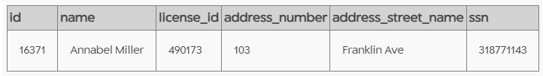

Now that we have identified our witnesses, the next logical step would be to check their statements or interviews about the murder. Based on the database schema provided earlier, we should look at the interview table.

Let's query the interview table for both witnesses:

**SELECT person_id, transcript**

**FROM interview**

**WHERE person_id IN (14887, 16371);**

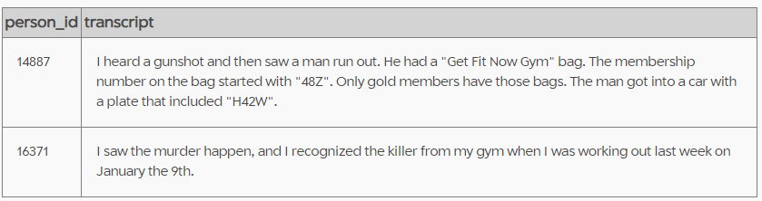

Morty Schapiro's statement:

1. Heard a gunshot
2. Saw a man run out with a "Get Fit Now Gym" bag
3. The bag's membership number started with "48Z"
4. Only gold members have these bags
5. The suspect's car plate included "H42W"

Annabel Miller's statement:

1. She witnessed the murder
2. She recognized the killer from her gym
3. She saw the killer at the gym on January 9th

Based on these statements, we can pursue the following leads:

1. Check the get_fit_now_member table for members with IDs starting with "48Z" and gold status:

**SELECT \***

**FROM get_fit_now_member**

**WHERE id LIKE '48Z%' AND membership_status = 'gold';**

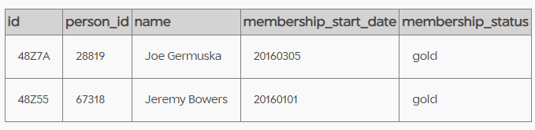

1. Cross-reference the results with the drivers_license table to find a match for the partial plate number "H42W":

**SELECT p.*, dl.\***

**FROM person p**

**JOIN drivers_license dl ON p.license_id = dl.id**

**JOIN get_fit_now_member gf ON p.id = gf.person_id**

**WHERE gf.id LIKE '48Z%'**

**AND gf.membership_status = 'gold'**

**AND dl.plate_number LIKE '%H42W%';**

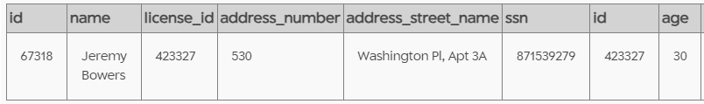

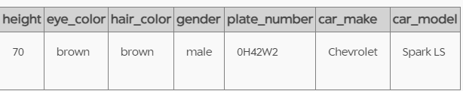

1. Check the get_fit_now_check_in table for members who were at the gym on January 9th:

**SELECT gf.*, p.name**

**FROM get_fit_now_check_in gc**

**JOIN get_fit_now_member gf ON gc.membership_id = gf.id**

**JOIN person p ON gf.person_id = p.id**

**WHERE gc.check_in_date = 20180109;**

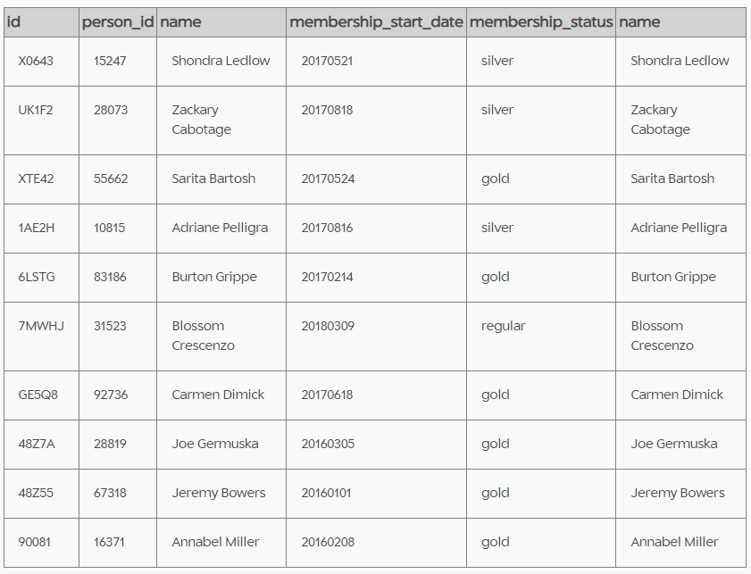

based on the available evidence, Jeremy Bowers is the most likely suspect in this murder case.

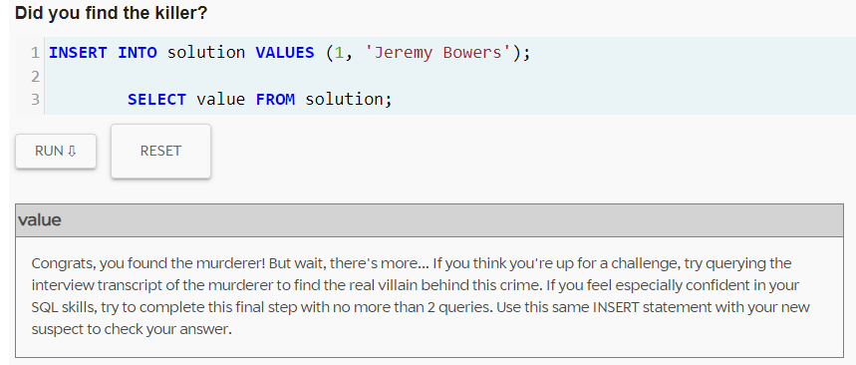

Let's start with retrieving Jeremy Bowers' interview transcript:

**SELECT transcript**

**FROM interview**

**WHERE person_id = (**

**SELECT id**

**FROM person**

**WHERE name = 'Jeremy Bowers'**

**);**

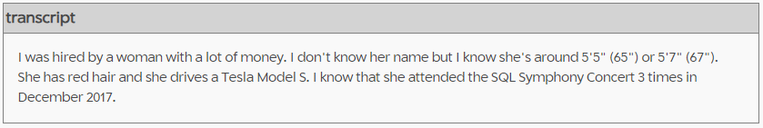

single query to find this person using the information we have:

**SELECT p.id, p.name, p.address_number, p.address_street_name, p.ssn**

**FROM person p**

**JOIN drivers_license dl ON p.license_id = dl.id**

**JOIN income i ON p.ssn = i.ssn**

**JOIN facebook_event_checkin fec ON p.id = fec.person_id**

**WHERE dl.gender = 'female'**

**AND dl.hair_color = 'red'**

**AND dl.car_make = 'Tesla'**

**AND dl.car_model = 'Model S'**

**AND dl.height BETWEEN 65 AND 67**

**AND fec.event_name = 'SQL Symphony Concert'**

**AND fec.date BETWEEN 20171201 AND 20171231**

**GROUP BY p.id, p.name, p.address_number, p.address_street_name, p.ssn**

**HAVING COUNT(DISTINCT fec.date) = 3**

**ORDER BY i.annual_income DESC**

**LIMIT 1;**

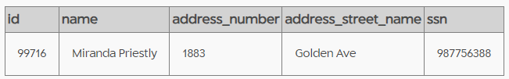

Miranda Priestly fits all the criteria provided by Jeremy Bowers in his interview:

